# Project Design Phase-I Solution Architecture

|  |  |
| --- | --- |
| Date | 23 September 2022 |
| Team ID | PNT2022TMID51631 |
| Project Name | IOT Based Smart Crop Protection Based on  Agriculture |
| Maximum Marks | 4 Marks |

**Solution Architecture:**

Solution architecture is a complex process – with many sub-processes – that bridges the gap between business problems and technology solutions. Its goals are to:

* Find the best tech solution to solve existing business problems.
* Describe the structure, characteristics, behavior, and other aspects of the software to project stakeholders.
* Define features, development phases, and solution requirements.
* Provide specifications according to which the solution is defined, managed, and delivered.

# Solution Architecture Diagram:

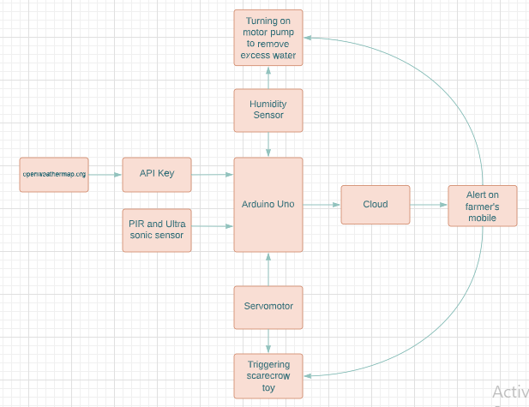

*Figure 1: Architecture and data flow of the voice patient diary sample application*

**Reference:** [**https://aws.amazon.com/blogs/industries/voice-applications-in-clinical-research-**](https://aws.amazon.com/blogs/industries/voice-applications-in-clinical-research-powered-by-ai-on-aws-part-1-architecture-and-design-considerations/)[**powered-by-ai-on-aws-part-1-architecture-and-design-considerations/**](https://aws.amazon.com/blogs/industries/voice-applications-in-clinical-research-powered-by-ai-on-aws-part-1-architecture-and-design-considerations/)